- Overall development challenges, opportunities, and risks
- General development challenges including poverty, equality/inequality, national development plan/poverty reduction strategy, humanitarian assessment.

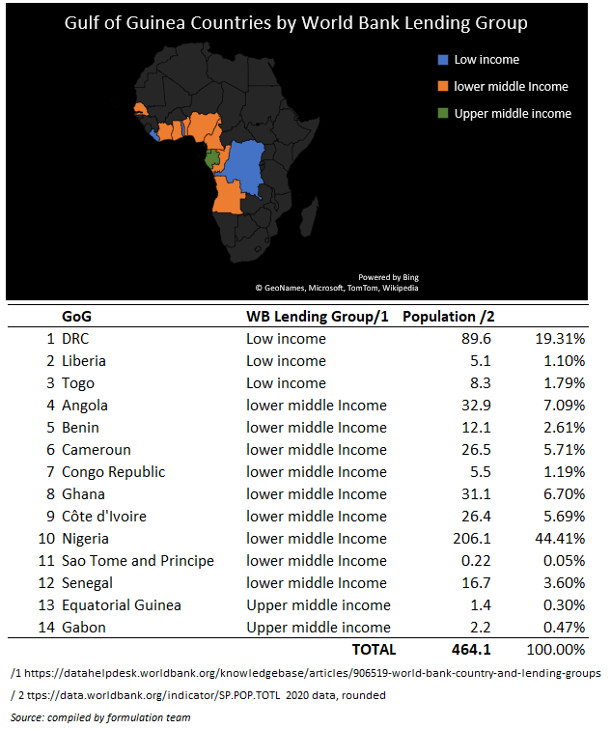
The Gulf of Guinea (GoG) is a vast maritime zone of 2.3 million square kilometres and 6,000 kilometres of coastline. The GoG basin countries include low-income countries (LIC) Democratic Republic of Congo, Liberia and Togo, low-middle-income countries (LMIC) (Angola, Benin, Cameroun, Congo Republic, Ghana, Nigeria Côte d’Ivoire, Sao Tomé and Principe and Senegal), and upper-middle-income countries (UMIC) Equatorial Guinea and Gabon. According to the World Bank (2020), the total population in these countries is 464 million, with more than 4 out of 10 people living in Nigeria.

With 60 per cent of Africa’s oil production, the Gulf of Guinea is home to 4.5 per cent of the world’s proven oil reserves and 2.7 per cent of proven natural gas reserves. Two-thirds of these reserves are concentrated within the exclusive economic zone of Nigeria, the centre of gravity of the region, whose oil sector accounts for 75 per cent of the state’s revenue and 90 per cent of total exports.

The Gulf of Guinea also has one of the world’s richest fishing grounds and represents almost 4 per cent of global fish production. The fisheries sector is a critical source of employment for millions of people. In West Africa alone, up to a quarter of jobs are linked to the fisheries sector. These resources contribute to the economic dynamism of the region, and its economic potential is expected to increase in the coming years (the region will comprise a quarter of the world’s population by 2050). However, before it can realise and benefit from this potential several threats to its stability and prosperity must first be addressed.

The coastal countries face multiple and complex challenges related to social and economic development, governance (including corruption), environmental pressures, human rights, and security (including terrorism, civil unrest, and piracy). Climate induced sea level rise (SLR) is also an issue facing several countries.

Asymmetrical terrorist attacks have been carried out against national and international security forces, local authorities, and civilians in several countries, notably Burkina Faso, Mali, Niger, and Nigeria. Violent extremist armed groups continue to harass civilians, carry out targeted abductions or killings of suspected informants or local Representatives of States, burn down schools and threaten teaching staff. Piracy and armed robbery in the Gulf of Guinea is also highlighted as an increasing risk, with criminal groups increasingly resorting to hostage taking. Drug smuggling and trafficking of small arms and light weapons, carried out partly by terrorist groups, pose serious challenges in the sub region.

The growing threat of cross border armed groups and transnational organised crime continue to be compounded by weak state institutions and the inadequate provision of public services.

UNDP’s Human Development Index (HDI) highlights that all countries in the region rank below top 100 and with considerable differences between them. Where, e.g., Gabon ranks 110 with a HDI score of 0.702, Togo is only ranked 165 out of 189 countries with a score of 0.503. This indicates that the life expectancy, the educational system, and the economic development in the region is well below average on a global scale. Significant income inequalities exist between cities and rural areas, and the most striking example is probably Nigeria. Statistics show substantial differences in Nigeria between the Federal States in the northeast, for example, and those in the south-west, both in terms of incomes, education, and health indicators.

Governance indicators vary. Whereas Ghana and Benin rank above average on a global scale, when considering, e.g., voice and accountability, Equatorial Guinea scores very poorly and has even worsened in the past decade. Gabon has also worsened in this period, while Nigeria and Togo have improved, though from a level below average. Ghana provides an interesting example of an ambitious attempt being made to fight inequality with their regionalisation policy, which aims to develop the north of the country to achieve real progress in school enrolment, access to healthcare, and support for local economic activities.

The humanitarian situation in parts of West Africa and the Sahel remains critical, mainly due to food insecurity, forced displacements and chronic vulnerability to external shocks. In the Lake Chad basin area, which has been affected by extreme climatic conditions, 4 million people are currently classified as facing food insecurity. Across the Sahel, some 6.9 million people, 3.7 million of them in north-eastern Nigeria alone, are in food crisis. Insecurity in certain areas is also causing people to migrate in certain areas, mostly in the Sahel.

- Development in key economic indicators: GDP, economic growth, employment, domestic resource mobilisation, etc.

After experiencing growth rates of 3.4-3.6% in 2018-2019 (which were projected to continue before the global pandemic hit), the GDP of the West African region contracted -1.5% in 2020 as a result of COVID-19 (African Development Bank, November 2021). Of major factors in this downturn was the region’s reliance on tourism combined with the fact that many of the countries rely on commodity exports and essential foodstuff import – with prices on the former decreasing and the latter increasing due to the pandemic. Vulnerable groups including women, young people, and informal workers have been hit disproportionally by this economic downturn. The African Development Bank (November 2021) project West Africa’s economy to recover in 2021 as a result of more effective vaccines, sustained government stimulus policies, and potential acceleration in digital transformation. However, risks such as lower commodity prices and slower tourism recovery remain.

Except for Nigeria, all West African countries became signatories to the African Continental Free Trade Area (AfCFTA) agreement in Kigali on 21 March 2018.

Nigeria is the economic epicentre in the Gulf of Guinea due to the importance of its economy and its large population. The centrality of oil in the economy offers a great potential but is also seen as cause of some of the problems, not only in Nigeria, but also in the region as a whole. Oil extraction – and oil spilling – leads to a continuous degradation of the coastal environment, which hampers fishing and agriculture by making land infertile.

There are considerable differences in Gross Domestic Product (GDP) and Gross National Income (GNI) between the countries in the region. While Equatorial Guinea and Gabon have the highest GNI per capita in Africa (USD 19,513 and USD 16,413 respectively), most of the other countries, and in particular Togo and Benin, rank very low on a global scale (USD 1,453 and USD 2,061). The availability of natural resources is key in explaining the considerable regional GNI differences, but it is by no means a guarantee of a well-functioning economy and society as is the case in the Niger Delta, the poorest part of Nigeria with the largest oil reserves in West Africa.
The Nigerian economy, being the key driver for the region overall, grew at a rate of 7% during the last decade. However, in the same period unemployment doubled and Nigeria’s youth unemployment figures have been reported as being the worst in Sub-Saharan Africa. Therefore, despite a considerable level of economic activity and opportunity, Nigeria has not managed to incorporate its entire population. Youth unemployment rates across the region are high and this incentivises criminal activities such as oil theft, armed robberies or trafficking, as they can be the only sustainable financial opportunities available. The challenge for most of the countries is to create a sustainable and inclusive economy, which is not overly dependent on oil and other natural resources.
Growth in West Africa trade is closely linked to increases in the region’s ability to facilitate it – and has reportedly fuelled an increasing reliance on container handling leading to congestion at key ports where infrastructure is approaching its capacity limit. To improve the performance of their terminal operations, West African governments have increasingly turned to foreign firms, Bolloré (France) and APM terminals (Denmark), that now handle three-quarters of all containers passing through the region’s ports. Ports such as Lomé, Tema (Ghana), Lekki (Nigeria), and Abidjan have been enhanced to cater for deeper draft vessels. The effect of this is reported to have been an increase in effectiveness, albeit with an increase in operating costs as well. As discussed further below, there is also a link between the ability to effectively handle maritime traffic and security (piracy/armed robbery) issues.
- Status and progress in relation to SDGs, in particular those that are special priorities for Denmark.

Status of and progress towards achievement of the SDGs lags in all prospective beneficiary countries of the DMSP 3. Concerning the SDGs that are particularly relevant to the programme (SDG5, 14. 16 and 17), the yellow highlighted elements of the below table show status and trends.
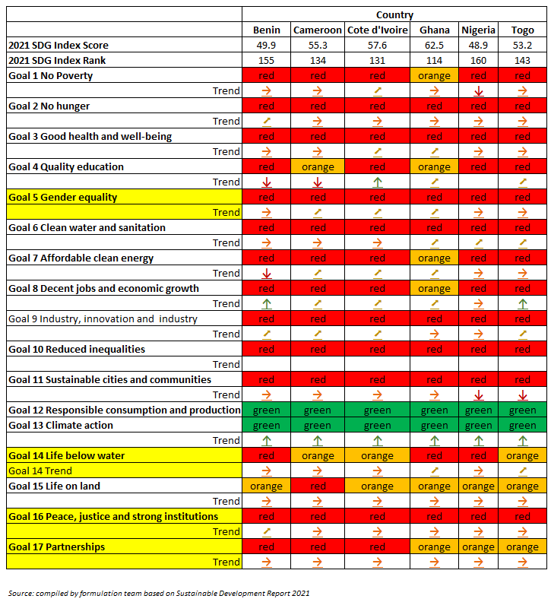
Trend colour coding and tendency:

Green : SDG Achievement Orange : Significant challenges remain Red : Major challenges remain

: On track : Moderately increasing : Stagnating : Decreasing

- Political economy, including drivers of change (political, institutional, economic)

The region’s political economy is influenced by the interplay between governance factors and economic interests. Shortcomings in terms of justice and rule of law contribute to a culture of impunity. In this section, we draw from the World Governance Indicators to illustrate where some of the key stress points lie in the political economy of the two focus countries – Nigeria and Ghana.

World Governance Indicators show considerable differences in the governance of the two countries with Ghana outperforming Nigeria in all aspects. Historically, Ghana has performed quite well on a global scale when it comes to fighting corruption. Ghana has, however, seen a decline in its performance since 2014 (from a score of 48 to 40 on T.I.’s CPI) but is still way ahead of most of their GoG counterparts where Nigeria scores 27.

On other governance indicators, Ghana has consistently maintained a positive rule of law score since 2011. Ghana is currently scored 0.13 in its rule of law. Nigeria has performed (relatively) well in this WGI as it was sitting at its highest score to date in 2017 – score being -0.87.

Ghana has experienced steady improvement in scoring on Voice and Accountability since 2000 where it began at a score of 0.07 that in in 2017 had been converted to a score if 0.59, consistently outperforming Nigeria who has never had a positive WGI score on this indicator. For Nigeria, the scores have fluctuated since 2000, experiencing a steady improvement since 2009 until recently where they in the final year of scoring again decreased to -0.34.

Ghana’s score for Political Stability and Absence of Violence peaked in 2011 with a score of 0.17, where it then experienced decline most years except for 2015. It currently sits at 0.09, placing it still well above Nigeria, who has (again) never experienced a positive WGI score on this indicator. Nigeria currently sits at a score of -1.94, with small fluctuations in its score since 2000, and has never risen above -1.46.

Ghana’s Government Effectiveness score has recently improved to -0.11 in 2017 after experiencing a 14-year period of consistent decline until 2015. Nigeria has been much more unstable, consistently fluctuating between improvement and decline since 2013. In the last year of data (2017), this score improved from -1.09 to -0.96.

Ghana has seen a decline in its regulatory quality since 2010 (0.12), currently processing at a score of -0.14. Nigeria performs its best in this category although very minimal improvement has been seen in recent years. The 2017 score (-0.89) was an improvement from the previous year but still far from its peak score (-0.66) in 2013.

In Nigeria, this is demonstrated by oil governance, where the Nigerian government subsidises fuel imports thus keeping prices at around one-third of its price in neighbouring countries, which reportedly also incentivises oil smuggling into neighbouring countries. While the oil sector in Nigeria is responsible for 90% of exports, 80% of government revenue, and 40% of GDP, the oil industry provides employment to only two to three percent of the population. In that sense, oil dependency neither compensates local communities through increased livelihood opportunities, nor incentivises the state to invest in sectors offering more employment opportunities.

The risk of this construction is that the governing elites tend to become more detached from their citizens because the state does not rely on their taxation. This has several potential effects such as an increased authoritarianism of the political system and a turning of politics into a rent-redistribution mechanism. However, these effects depend on the quality of institutions before the natural resources are discovered and the political coalitions. In that sense, GoG countries are often presented as the ‘worst-case scenario’ among resource wealthy states since the politics of many of these states already appeared dysfunctional before oil discovery, which in turn only ‘exacerbated previous shortcomings and created new ones’.

Ghana is a newer oil producer, but potentially with some of the same inherent challenges where rivalry among political coalitions seem to undermine the tangible benefits.

Both Nigeria and Ghana are members of ECOWAS, which essentially is an economic and political union with the ambition of promoting economic cooperation and regional integration as a tool for an accelerated development of the West African economy. ECOWAS is regarded as a positive factor in the political economy of the region, although its impact is perhaps more declaratory than practical.

In relation to maritime security governance, both Ghana and Nigeria have several government and private sector stakeholders with leading agencies being the Ghana Maritime Authority (GMA) and the Nigerian Maritime Administration and Safety Agency (NIMASA). Yet, the degree of inter-agency interaction needs strengthening, which is one of the goals of the present programme. A key goal here will be to coordinate the different interests and capacities of the stakeholders involved. In Ghana, a National Maritime Security Committee has been established and this provides a possible nucleus for more substantive inter-agency coordination. In Nigeria, such a body has yet to develop, although a possibility exists through operationalisation of the Maritime Operations Control Centre under the Office of the National Security Advisor.

- Key documentation and sources for this analysis

See footnotes.

- Additional studies and analytic work needed

PSED 3 (KAIPTC) includes the development of research-based knowledge products to form the basis of activities of the other two project pillars (i.e., dialogue and capacity building). The research component will explore the following broad issue areas: Gender, youth, and other at-risk groups in maritime security; interface between on-sea and on-land maritime criminality in the Gulf of Guinea; coordinated maritime norms and institutions and mechanisms for collaborative responses to safety and security in the Gulf of Guinea; and Women Peace and Security in the maritime domain. Where relevant synergies with other DMSP 3 engagements will be exploited in joint research.

- Fragility, conflict, migration, and resilience
- Identifying on-going stabilisation/development and resilience efforts and the potential for establishing partnerships and alliances with national, regional, and other international partners to maximise effects of the engagements

Maritime crime is a significant threat to seafarers, international trade, and sustainable economic growth in the Gulf of Guinea region. About 90 per cent of the region’s international trade is moving by sea. The region has become the world’s piracy hotspot and accounted for more than 40 per cent of all piracy-related incidents and 90 per cent of all kidnappings at sea in 2020. The Gulf of Guinea experienced a nearly 50 per cent increase in kidnapping for ransom between 2018 and 2019 and around a 10 per cent increase between 2019 and 2020. The region now accounts for over 90 per cent of all kidnappings for ransom at sea. Despite efforts by coastal countries and external actors, the Gulf of Guinea remains highly insecure, with acts of piracy now extending from Ivory Coast to Congo-Brazzaville. Twenty-five (25) successful piracy attacks resulted in 142 kidnapped seafarers in 2020. The International Maritime Bureau’s (IMB) latest global piracy report records 38 incidents since the start of 2021 – compared with 47 incidents during the same period last year. In the first three months of 2021, the IMB Piracy Reporting Centre (PRC) reported 33 vessels boarded, two attempted attacks, two vessels fired upon, and one vessel hijacked.

The UNODC-MFA Report on piracy (2021) provides seminal insight into political economy factors and trends in piracy and other maritime crimes. The Niger Delta region in the south-southeast of Nigeria remains the epicentre of maritime insecurity. The Niger Delta region represents USD 400 billion in contributions to Nigerian GDP annually represented by oil and gas production.,

Nigeria faces numerous security challenges not only in its EEZ, but also in the waterways and creeks of the Niger Delta. Challenges include oil theft, refining oil, smuggling, militancy, community struggles, cultism, and maritime criminality, including piracy.

Nigeria has a vast exclusive economic zone (EEZ) of 217,000 km². The Niger Delta region, in the south-southeaster region, is characterised by almost 2,000 waterways winding deep into the territory. These characteristics of Nigeria’s maritime landscape are important for how piracy is conceptualised. The study delineates three types of pirate and maritime criminal groups, which operate in the region. (1) Deep Offshore Pirates can operate far from the coast of West Africa and target international shipping traffic. Deep Offshore pirate groups have become increasingly more sophisticated as, for example, seen in their ability to take more hostages per attack. These groups have expanded their geographic reach further into the Gulf of Guinea, thereby changing the previous general picture of incidents mostly concentrated in Nigerian waters. The number of Deep Offshore pirate groups is estimated to be between four and six. (2) Coastal and Low-Reach Pirates operate up to 40nm from shore, primarily targeting local vessels. These groups usually operate close to their hideouts, or bases, onshore and have a limited operational range capacity. The targets are mainly fishing vessels operating along the coast, oil and gas support vessels and cargo vessels, and tankers engaged in cabotage operations. Their modus operandi includes looting, racketeering, and kidnapping for ransom and is focused more on local crew than on foreign seafarers. (3) Riverine Criminals are often referred to locally as ‘pirates’, though their criminal activity does not fall under the UNCLOS definition of piracy as they operate in the waterways deep within the Niger Delta where they target local passenger vessels and engage in other crimes. Some arrests of ‘pirates’ reported by Nigerian agencies and media are most likely of Riverine Criminals and illegal oil bunkerers arrested in the creeks of the Niger Delta. These groups pose a more immediate security threat to local populations in the Niger Delta region than to international vessels and their crews.

The region’s challenges are many and intertwined. Widespread poverty constitutes a major issue (70 percent of the Niger Delta population of approximately 30 million people lives below the poverty line of USD 1.90/day). In 2020, the Nigerian National Bureau of Statistics indicated that more than 33 per cent of the population is unemployed. At the same time, the Niger Delta is one of the most polluted in the world. Environmental degradation related to oil pollution of the marine environment has depleted the fishing and water resources that people have traditionally depended on for their livelihoods.

This has led to a complex pattern of conflicts in the region since the late 1990s. The contrast of a high rate of poverty in the Niger Delta and simultaneously an enormous oil wealth has been clearly depicted in the 2015 United Nations’ Multi-Dimensional Poverty Index. This very juxtaposition was a major motivating factor for early militant groups operating in the region. In 2005, the politically motivated Movement for the Emancipation of the Niger Delta (MEND) started staging attacks against oil and gas infrastructure. For years, early militant groups like MEND posed the main threat in the Gulf of Guinea. However, opportunistic criminal groups purely motivated by profit later took their place, attacking vessels across the Gulf of Guinea.

Though ex-militants still influence contemporary piracy, the nature of the link between politically motivated militancy and piracy has changed significantly. Pirate groups have displayed considerable improvements in both the degree of organisation and capability. This includes well-organised pirate hostage camps in border regions close to Cameroon, a wider nautical range of attacks, and a shift from almost exclusively night-time attacks to roughly 50 per cent of attacks taking place during daytime.

There has been shift away from ‘petro piracy’ to ‘kidnap & ransom piracy’ as a new piracy business model. An increase in the value of ransom payments has also been observed in recent years. For example, the initial demand for ransom for abducted crews was between 20 and 25 million Naira (USD 100,000-150,000) in 2008, and the final agreement was around five to six million Naira (USD 25,000).

In 2016, the agreed-upon figure rose five-fold to USD 125,000-150,000 for one group of hostages. Continuing this trend, ransom rates have as of 2020 increased to a level of between USD250,000-300,000 per group. With this increase, there has also been a shift from ransom being paid in Nigerian Naira to ransom paid in US dollars. Niger Delta-based pirate groups’ illicit gains amounted to roughly USD 4 million in ransom payments in 2020 alone. Between 2016 and 2021, hostage for ransom has affected markedly more non-Nigerians year after year.

Corruption and collusion are enabling factors in the commission of a range of organised crime activities, including piracy and the oil theft business, particularly for top-level actors such as ex-militants, sponsors, and protectors. Corruption and the structure of pirate groups are two sides of the same illicit coin. Kingpins and Sponsors are responsible for organising and providing the financial support to launch piracy attacks. Actors at this level may include high-level ex-militants, who help facilitating incidents of piracy - for example by making funds available for initial investments (equipment, fuel, weapons, etc.). Actors at this level are likely also critical in providing protection and cover for the pirate groups. Other roles include a hierarchy of Group Leaders, who oversee initial attacks against vessels, including the kidnapping of seafarers. Specialised Team Members possess a specific skillset to the attack team, such as navigation or engineering capabilities or the ability to hang grappling ladders on vessels being attacked. Attack Team General Members, Camp Guards, and Onshore Support Roles are used following a successful kidnapping operation and manage operations at the hostage camps onshore in the Niger Delta. These roles include guarding of captive hostages and providing general operational support for the camp. The larger share of pirate money streams goes to sponsors and kingpins. Collusion practice include pirates paying certain members of official security forces to “turn a blind eye” to various parts of the criminal activities of pirate groups.

Danish and international efforts to combat piracy and other maritime crimes have contributed to significant drops in the number of global piracy and maritime crime incidents. In West Africa, Nigeria saw the first convictions of three pirates in August 2020 followed by the conviction of nine more pirates in Togo in July 2021. However, the region has continued to experience increased incidents of piracy and other maritime crimes at an alarming rate, including drug trafficking, firearms trafficking, fisheries crimes, and human trafficking and smuggling of migrants. Thus, the overall security situation in the Gulf of Guinea region is deteriorating with rising numbers of piracy and other maritime crimes occurring unabated. Piracy and other maritime crime related financial flows feed on land crime networks of kingpins, sponsors interlinkages with corrupt officials, and have become bolder and more capable deep offshore pirates who target international shipping traffic as well as coastal low-reach pirates who operate up to 40 nautical miles from shore and primarily target local vessels. The coastal states do not yet possess the capacity to exercise sufficient authority and sovereignty at sea.

Maritime insecurity directly affects Danish foreign policy interests as Danish shipping companies, port operators, and providers of offshore supplies and services have significant interests and substantial presence in the Gulf of Guinea region. In 2020, 5 per cent of Danish shipping exports were to West Africa, equivalent to DKK 8 billion. At any given time, an estimated 30-40 Danish operated vessels are in the Gulf of Guinea, making more than 2,600 port calls a year.

The activities of pirates and other criminals at sea are not only plaguing the Gulf of Guinea. They also have dire economic consequences for coastal countries, the local population, and international shipping companies – including Danish companies, who have invested millions of dollars in contracting security personnel and paying insurance premiums for their vessel and crew. With the rising number of piracy and maritime crime incidents in the region, international support for national and regional maritime security initiatives will be crucial in ensuring improved maritime security in the region.

Many challenges have contributed to the growing maritime insecurity in the region, with a central one being the absence of effective law enforcement present at sea and anti-piracy legislation in land, which makes it difficult to prosecute pirates and other maritime criminals. After the adoption of the Yaoundé Code of Conduct, maritime laws or amendments to penal codes were expected to be implemented throughout West Africa to standardise legal regimes. However, only five countries (November 2021), Nigeria, Togo, Liberia, Sierra Leone and Cape Verde, have since passed anti-piracy legislation, making it challenging to coordinate piracy responses in the region. The Maritime Security Index developed by Stable Seas shows considerable variation across the DMSP 3 beneficiary countries.
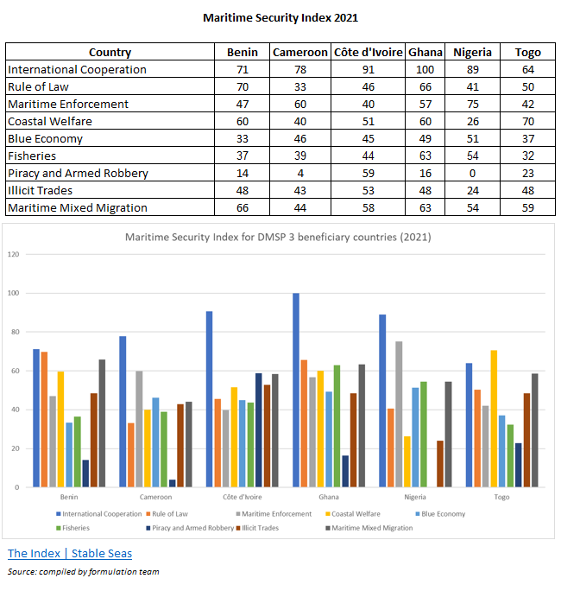
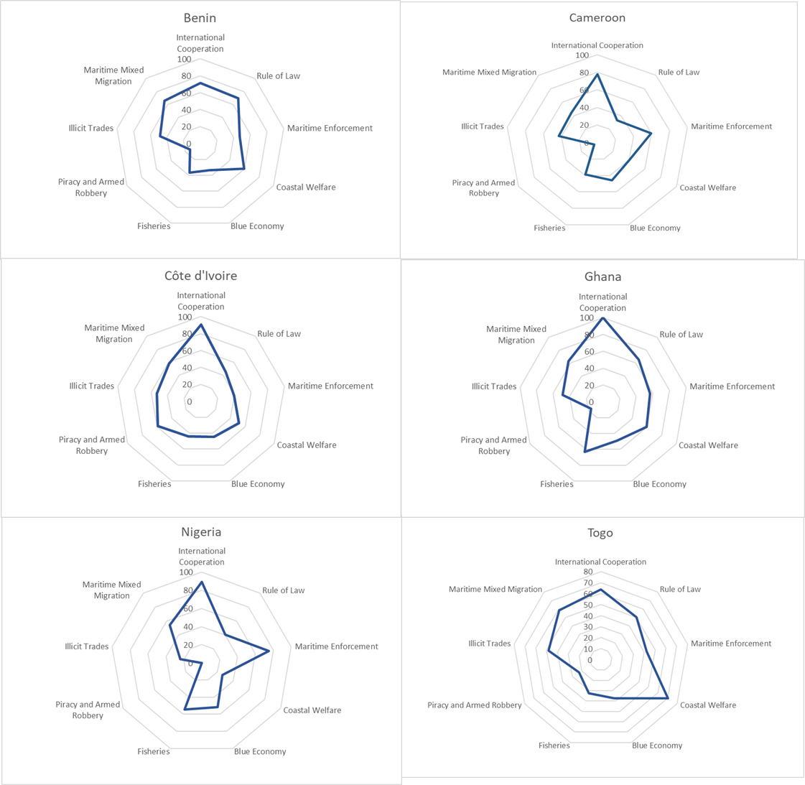

The region is developing a cooperation architecture to respond to the piracy threat and institutional weaknesses described above. UN Security Council Resolutions 2018 (2011) and 2039 (2012) urged regional states to increase their anti-piracy cooperation, develop and implement national maritime security strategies, establish legal frameworks, develop and implement transnational and transregional coordination centres, and encouraged international partners to support these efforts. Steps towards this are being taken through the Yaoundé Code of Conduct and the African Union and ECOWAS integrated maritime strategies (AIMS and EIMS). These cover a range of maritime issues, including the blue economy (trade, fishing, etc.), environmental protection, disaster management, legal matters, as well as maritime security).

The 2013 Yaoundé Code of Conduct focuses on six pillars: (1) common information management, (2) local surveillance measures, (3) legal and functional harmonisation of maritime operations, (4) self-financing through a community tax, (5) purchase and maintenance of equipment dedicated to the strategy, and (6) the institutionalisation of a maritime conference for Central Africa.

The AU’s maritime strategy (AIMS) document notes several maritime domain threats, including transnational organised crime (such as money laundering, trafficking in arms, drugs and people, piracy and armed robbery at sea, illegal oil bunkering, and maritime terrorism), illegal, unreported, and unregulated fishing (IUU Fishing) and overfishing, environmental crimes, natural disasters, environmental degradation, and climate change. It also notes a range of weaknesses, including in relation to communications, legal frameworks, absent or poorly maintained aids to navigation and modern hydrographic surveys. In relation to piracy and armed robbery at sea, the AU encourages its members to promote (1) burden sharing, (2) tracking financial flows, (3) sharing and reporting relevant information, (4) interdicting ships and/or aircraft suspected of engaging in piracy or armed robbery against ships, (5) apprehension and prosecution of persons committing or attempting to commit piracy or armed robbery against ships, and (6) facilitating proper care for individuals subjected to piracy/armed robbery at sea.

ECOWAS’ strategy (EIMS) identifies the major challenges to the maritime domain and offers a set of comprehensive priority actions that should be undertaken at the national and regional level. It addresses five strategic objectives: (1) strengthening maritime governance, (2) maritime security and safety, (3) maritime environmental management, (4) optimising the ECOWAS maritime economy; and (f) promoting maritime awareness and research. Inter alia, it notes the importance of criminal justice responses based on a solid foundation of the rule of law, the need for coordination and cooperation, and effective governance. These responses need to cover policy directives or regulations supported with standard operating procedures (SOP), compliance monitoring and evaluation mechanisms to ensure effective national implementation, and strengthened criminal justice enforcement regimes on maritime matters at national level.

ECOWAS’s efforts to provide a framework for strengthening maritime security (as with ECCAS to the south) need to be seen in the context of the African Peace and Security Architecture (APSA) and the African Governance Architecture (AGA). As regional economic communities (RECs), both ECOWAS and ECCAS contribute to APSA and AGA by strengthening sub-regional cooperation on key security and governance issues, including countering piracy, governance, and the rule of law. ECOWAS’ Integrated Maritime Strategy provides a vehicle for this.

In support of the operational aspects of Yaoundé, a regional architecture is being established based on an Inter-regional Coordination Centre (ICC in Yaoundé, two regional maritime operation centres (one in West Africa and one in Central Africa), a series of multinational maritime cooperation centres (MMCCs) based on a zonal approach through which coastal states are grouped into six zones. The MMCCs are linked to national Maritime Operation Centres (MOCs) in each country. The overall purpose of this arrangement is to provide a mechanism whereby maritime information can be passed to neighbouring states and responses to illegal activity, environmental threats, and other incidents that may arise can be coordinated. As states’ territorial waters and economic zones can easily be transited and as states’ capacity to respond operationally varies, it is recognised that a regional approach is required.

- Issues and concerns of relevance to Danish interest in the area of security and migration.

In summary, Denmark has a direct interest in promoting maritime security in the region as an incentive to international trade (with a significant proportion of trade being via Danish operated vessels and through ports with Danish commercial interests) and thereby also reduce the risks to shipping companies and seafarers (including Danish). From a development perspective, Denmark has an interest in complementing other Danish development engagements and stimulating economic and social development and good governance. Stronger, regionally owned maritime security arrangements will contribute to a reduction in trafficking in drugs, weapons, and people; corruption and organised crime; and pressures leading to migration.

- Danish comparative advantages leading to more effective and efficient programming and better results, including areas where Denmark contributes with expertise and capacities.

Denmark’s comparative advantages concerning maritime security lie within the synergies available from combining security, trade, and growth initiatives, significant private sector involvement (Danish shipping industry), and political dialogue. Danish private sector involvement (APM) in key container ports raises Denmark’s profile in the sector.

The Danish defence has some existing experience from cooperation with likeminded partners in the areas of boarding and operational planning that can be drawn upon in this programme. There are political dialogue advantages available in Ghana and Nigeria due to the presence of the Danish Embassies in Accra and Abuja.

- Considerations regarding the humanitarian situation, migration, refugee, and displacement issues, including the need to integrate humanitarian-development linkages and long-term strategies

The programme is unlikely to have a direct impact on the humanitarian situation or migration patterns within the region.

- Relevant issues and considerations related to radicalisation and violent extremism and the potential for Danish engagement to prevent and counter violent extremism (P/CVE).

The programme is unlikely to have a direct impact on radicalisation and violent extremism. Strengthened law enforcement and improved justice sector effectiveness in line with international standards (including human rights) will contribute to improved governance and thereby reduce corruption and other governance weaknesses that underpin drivers of extremism – although these effects are likely to be relatively minor.

- Key documentation and sources for this analysis

See footnotes.

- Additional studies and analytic work needed
PSED 3 (KAIPTC) includes the development of research-based knowledge products to form the basis of activities of the other two project pillars (i.e., dialogue and capacity building). The research component will explore the following broad issue areas: Gender, youth, and other at-risk groups in maritime security; interface between on-sea and on-land maritime criminality in the Gulf of Guinea; coordinated maritime norms and institutions and mechanisms for collaborative responses to safety and security in the Gulf of Guinea; and Women Peace and Security in the maritime domain. Where relevant synergies with other DMSP 3 engagements will be exploited in joint research.

- Assessment of human rights situation (HRBA) and gender
- Human Right Standards (international, regional, and national legislation)

Reports indicate a generally mixed record with respect to human rights observance. In the following, the focus is on Ghana and Nigeria.

Regarding Nigeria, the most recent U.S. State Department assessment notes that the most significant human rights issues included extrajudicial and arbitrary killings; disappearances and arbitrary detentions; torture, particularly in detention facilities, including sexual exploitation and abuse; use of children by some security elements. Additional issues are; looting and destruction of property; civilian detentions in military facilities, often based on flimsy evidence; denial of fair public trial; executive influence on the judiciary; infringement on citizens’ privacy rights; restrictions on freedoms of speech, press, assembly, and movement; official corruption. On the WPS-agenda lack of accountability in cases involving violence against women and children, including female genital mutilation/cutting and sexual exploitation of children; trafficking in persons; early and forced marriages; criminalisation of status and same-sex sexual conduct based on sexual orientation and gender identity; and forced and bonded labour. It furthermore notes that the government took steps to investigate alleged abuses but fewer steps to prosecute officials who committed violations, whether in the security forces or elsewhere in the government. Impunity remained widespread at all levels of government.

Regarding Ghana, the U.S. State Department reported that the most significant human rights issues included excessive use of force by police, including torture, resulting in death and injuries; rape by police; harsh and life-threatening prison conditions; assault on and harassment of journalists; corruption in all branches of government. On the WPS-agenda lack of accountability in cases of violence against women and children, including female genital mutilation/cutting; early and forced marriage; sexual exploitation of children. Furthermore, infanticide of children with disabilities; trafficking in persons; criminalisation of same-sex sexual conduct, though rarely enforced; and exploitative child labour, including forced child labour. It notes that the government took steps to prosecute and punish officials, who committed abuses, whether in the security forces or elsewhere in the government, but impunity remained a problem.

- Universal Periodic Review

Nigeria’s most recent UPR was in 2018 after which the government accepted 230 recommendations and noted 60. The issues with the largest number of recommendations included international instruments, rights of the child, women’s rights, gender identity and sexual orientation related rights, and the death penalty.

Ghana’s most recent UPR was in 2017 after which the government accepted 213 of the recommendations and noted 29. Not accepted recommendations almost exclusively concerned decriminalisation of aspects and protection of rights related to sexual orientation and gender identity – with a few also dealing with the issue of discrimination of persons with albinism.

- Key rights holders in the programme

Rights holders in relation to this programme include seafarers and other individuals on board vessels operating in the Gulf of Guinea. A second group of rights holders are persons engaging in criminal activity (piracy and armed robbery), who have rights in relation to their safety and due legal process once apprehended. A third group of rights holders are citizens in the Gulf of Guinea countries. The programme is expected to primarily focus on the first two groups by strengthening law enforcement and justice within the maritime sector.

- Key duty bearers in the programme

The main duty bearers are governmental maritime agencies (GMA and NIMASA) and maritime law enforcement, including military (Ghanaian Navy and Nigerian Navy), coastguard, and police. A third group of duty bearers are national justice actors, who have the responsibility to ensure the right to a fair trial and legal process.

- Human Rights Principles (PANT)

Participation
- The focus of the programme lies some distance away from the ordinary citizens, although scope to engage them will be included in programme activities were relevant. This could be in relation to certain communication and dialogue activities (PSE 3). Aspects of PSE 1 and 2 may also reach broader constituencies (e.g., in relation to new legal measures and maritime strategies). The main barriers to this participation are (a) the technical nature of the engagements and (b) lack of experience of official stakeholders in communicating with a broader public. The programme will, however, use its implementing partners to assist in this respect. Contacts with NGOs engaged in the sector will be used as a way to achieve this, as well capacity building of journalists to report on maritime security issues (PSE 3).

Accountability
- The programme will promote the accountability of duty bearers (PSE 1 and 2) and those convicted of undertaking maritime crime (PSE 1). On the former, regular reporting on maritime security results achieved and work in progress will be prioritised – and facilitated through the development of maritime strategies and action plans.

Non-discrimination
- The programme will be implemented in a manner that is non-discriminatory, and non-discrimination will be highlighted were appropriate in the engagements (particularly PSE 1 and PSE 2).

Transparency
- See under accountability. The programme includes various possibilities to promote transparency – particularly PSE 3 where dialogue events will be open to a wider audience whenever this is feasible – and the results will be communicated to the broader public. The capacity of journalists to report accurately of maritime security issues will also be strengthened.

- Gender
- In 2020, women represented only 1.2% per cent of the global seafarer workforce as per the BIMCO/ICS 2021 Seafarer Workforce Report. This represents a positive trend in gender balance with the report estimating 24,059 women serving as seafarers, which is a 45.8% increase compared to the 2015 number.
- The full and meaningful participation of women in the economy, political decision-making, and society is key in addressing maritime challenges. Women contribute directly to coastal stability while playing important roles in solutions to maritime crime. Women’s income goes directly to the feeding of their families and benefiting communities at a rate greater than men’s. ³ Women strongly influence behaviour and decision making in their families and communities, and this role can be wielded to create positive change and prevent participation in criminal activity such as piracy.
- Maritime law enforcement is a largely male dominated work area. The programme will promote gender equality and women’s empowerment to a degree where women are involved in maritime law enforcement agencies and capacity development.

- Youth
- Youth are indirect beneficiaries of the programme (as a reduction in piracy and armed robbery at sea will reduce the risk that youth get involved in such activities), and it will be important that maritime strategies – under PSE 2 (in particular) – include approaches to youth. Youth aspects could also be included within PSE 3 (research and dialogue).

- Key documentation and sources used for the analysis
Relevant references and guidance may include:
- Universal Period Review (UPR) processes and analysis (http://www.ohchr.org/EN/HRBodies/UPR/Pages/Documentation.aspx)
- OHCHR country reports (www.ohchr.org)
- EU Human Rights Strategies
- Human Rights periodic reporting and Treaty Bodies monitoring of human rights in member states (www.ohchr.org/EN/HRBodies/Pages/TreatyBodies.aspx) http://tbinternet.ohchr.org/_layouts/TreatyBodyExternal/MasterCalendar.aspx?Type=Session&Lang=En
- International and regional human rights and HRBA principles and HRBA Guidance Note of 2013
Danish Institute of Human Rights (DIHR) Guide to understand the interlinkages between human rights and the SDGs (http://sdg.humanrights.dk)
- Additional studies and analytic work needed
Corruption risks may be included among the research areas for PSE 3.

- Inclusive sustainable growth, climate change, and environment
The programme is expected to have indirect benefits for sustainable growth through increasing safety for seafarers and thereby also facilitating easier maritime trade and access to the blue economy. It is not expected to have effects related to climate change. It will have indirect benefits for the ability of coastal states to better manage maritime environment challenges, including possible pollution from oil spillage and negative effects from illegal fishing.

The programme does not, however, include concrete activities in relation to these areas.
- Key documentation and sources for this analysis

See footnotes.

- Additional studies and analytic work needed

Growth and environmental aspects may be included amongst the research areas for PSE 3.

- Capacity of public sector, public financial management and corruption

The maritime law enforcement agencies have shortcomings in relation to their capacities in policymaking, enforcement, and service delivery – all concerning their ability to take multi-agency approaches, which are a pre-requisite for progress within maritime security. This assessment partly provides the rationale for supporting the concerned institutions (PSE 1,2,4).

Due to its focus on maritime security, the programme will not directly work on PFM issues.

Corruption within the maritime sector is regarded as a contributing factor to piracy, armed robbery at sea, illegal fishing, etc. However, with the limited funds available, and given the difficulty of adopting an effective anti-corruption programme in this area due to the vested interests and number of actors concerned, the programme will not address it directly.

- Key documentation and sources for this analysis
See footnotes.

- Additional studies and analytic work needed

Corruption risks may be included among the research areas for PSE 3.

- Matching with Danish strengths and interests, engaging Danish actors, and seeking synergies
Identify:  - where we have the most at stake – interests and values,  - where we can (have) influence through strategic use of positions of strength, expertise, and experience, and  - where we see that Denmark can play a role through active partnerships for a common aim/agenda or see the need for Denmark to take lead in pushing an agenda forward. | - All four PSEs involve risks relating to possible lack of uptake/traction among local counterparts. The impact of these will vary but are likely to include delays and the need for political dialogue, should they occur.  - The use of advisors (all PSEs) is both a mechanism for channelling external (incl. DK) expertise and mitigating the risks mentioned above.  - DK will pursue an active partnership at political level and via the technical experts. The partnership with UN agencies adds additional weight to these capacities.
- Brief mapping of areas where there is potential for increased commercial engagement, trade relations and investment, as well as involvement of Danish local and central authorities, civil society organisations, and academia. | - The programme will strengthen DK’s commitment to the blue economy in which the Danish private sector has a significant stake (both at sea and on land). The programme will thereby strengthen the DK embassies’ work in this area.
- Assessment of the donor landscape and coordination, and opportunities for Denmark to deliver results through partners including through multilaterals and EU. | - Donor coordination is weak and ad-hoc. DK is advocating for stronger arrangements, incl. via the G7++FoGG. The programme adds weight to these efforts through the establishment of a virtual donor coordination group (PSE 1).
- Key documentation and sources for this analysis:

See footnotes.

- Additional studies & analytic work needed

PSE 1 will include an inception phase in 2022 on a potential engagement into supporting prison infrastructure in the region.

- Stakeholder analysis
- Stakeholders interested in or affected by the programme, including donors

The key regional stakeholders are ECOWAS, ICC, and the other elements of the Yaoundé architecture. National stakeholders include the national maritime agencies (GMA and NIMASA), the Ghanaian and Nigerian navies, coastguards and police, and ministries of justice/prosecution services, defence, trade, and transport.

Key donors are EU, U.S., UK, France, and Germany. Key multilateral actors are IMO, UNODC, and INTERPOL.

- Key stakeholders, main interests, capacity, and contributions

As described above. Capacities of regional and national entities vary and are often determined by the resources made available by national budgets. These are deficient and an aspect highlighted during dialogue meetings (e.g., G7++). In general, coastal states contribute with manpower and basic infrastructure (offices), but as recent G7++FOGG meeting illustrates, these contributions are far from adequate and greater effort is required.

- Communication, coordination, and cooperation of stakeholders in this programme

Improving these aspects is the rationale for the Yaoundé architecture (and the arrangements for the MNCCs, MOCs, etc). There is a critical need to strengthen the implementation of the architecture so that national and regional authorities are better connected. DMSP 3 will contribute towards this goal.

- Lead stakeholder

The lead stakeholders at national level are generally the national maritime agencies (i.e., GMA and NIMASA), the Navy/coastguard, and ministries of defence, justice and trade. It is widely acknowledged that inter-agency relations need to be strengthened, as there is a tendency to operate in silos. At the regional level, the lead stakeholders are ECOWAS/ECCAS and the ICC. Also here, relationships can be further strengthened.

- Involvement of key stakeholders in the preparation and formulation process

The formulation team has not physical been in the region during the formulation visit. This was mainly due to COVID-19 restrictions. All consultations with key stakeholders in the region has thus been virtual. The Danish Defence has had contact with ICC.

In Ghana, the formulation team have meet with KAIPTC, representatives of Ghana Navy and, through the embassy, Ghana Maritime Authority.

In Nigeria, through the embassy, contact with Nigerian Maritime and Security Agency (NIMASA) as well as the Nigerian Navy.

Interpol is engaged in supporting the five beneficiary countries in their respective areas of focus through Project AGWE, and UNODC as well through the Project SWAIMS. Finally, KAIPTC is well-connected to regional stakeholders such as ECOWAS and ICC in their formulation process.

- Stakeholders likely to support or hinder the programme

Based on DMSP 2 it is expected that regional and national stakeholders (duty bearers) support the programme as they have interests in further strengthening their capacity.

- Potential strategies for engaging key stakeholders?

The programme’s strategy in this respect is:
- Implementing agencies (UNODC and INTERPOL) will continue their efforts to engage stakeholders and as part of this will seek agreement to (a) the overall scope of the engagements (this has already largely been done in Ghana and partly in Nigeria) and (b) have the concrete input areas and modalities envisaged. PSE 3 will launch following programme approval with initial research that will enable the development of a detailed plan for further research and dialogue activities and associated training.

- The Danish embassies will be in regular contact with regional and national stakeholders as well as with like-minded partners in Ghana and Nigeria.

- PSE 3 will include a dialogue platform through which key stakeholders will regularly meet and discuss maritime security issues. This will provide an important mechanism for raising and exploring concrete thematic issues.

- Stakeholders offering best overall prospects in terms of possible partnerships

The most useful partnerships are expected to be with GMA and NIMASA as these institutions have the overall mandate for maritime safety and contacts with other agencies, including law enforcement and the justice machinery.

- Key documentation and sources for this analysis
Information gained from formulation mission and subsequent contacts with proposed implementing partners.

- Additional studies and analytic work needed.

A Transatlantic Approach to Address Growing Maritime Insecurity in the Gulf of Guinea | Centre for Strategic and International Studies (csis.org)
” Gulf of Guinea Resources, Economy and Development: Yesterday, Today and Tomorrow”, Babagana Abubakar, 2016
Report of the Secretary General on West Africa and the Sahel, 29 June 2018.
Human Development Index 2018
Ibid
Worldwide Governance Indicators 2007-2017
https://ideas4development.org/en/inequalities-in-west-africa-north-south-divide/
UNSG report, June 2018
UNSG report, June 2018
“Fragility, Violence and Criminality in the Gulf of Guinea”, Applied Knowledge Services, Elisa Lopez Lucia, 2015
“Fragility, Violence and Criminality in the Gulf of Guinea”, Applied Knowledge Services, Elisa Lopez Lucia, 2015
Human Development Index 2018
“Securing Development and Peace in the Niger Delta: A Social and Conflict Analysis for Change”, Paul Francis, 2012
Nigeria Stability and Reconciliation Programme (NSRP), 2014
Chatham House, 2013
West Africa is Expanding its Maritime Ports to Accommodate Growing Container Trade, U.S. International Trade Commission (USITC), May 2018
Worldwide Governance Indicators 2007-2017
Transparency International’s Corruption Perception Index 2012-2017
The WGI uses scoring between -2.5 to +2.5, with higher values corresponding to a superior performance on the indicator, or better governance.
UNODC 2013
“Fragility, Violence and Criminality in the Gulf of Guinea”, Applied Knowledge Services, Elisa Lopez Lucia, 2015
Ibid
“Party Politics and the Political Economy of Ghana’s Oil”, Mohan 2017
www.ecowas.int
Pirates of the Niger Delta (2021) UNODC and Ministry of Foreign Affairs Denmark
How oil and water create a complex conflict in the Niger Delta (theconversation.com)
Pirates of the Niger Delta (2021) UNODC and Ministry of Foreign Affairs Denmark
Pirates of the Niger Delta (2021) UNODC and Ministry of Foreign Affairs Denmark
Pirates of the Niger Delta (2021) UNODC and Ministry of Foreign Affairs Denmark
The Index | Stable Seas
African Integrated Maritime Strategy (AIMS), African Union, 2012
The zones most relevant for PSE 4 are zones E (that includes Nigeria) and F (that includes Ghana). The MMCCs for these zones are in Benin and Ghana respectively.
The purpose of the analysis is to facilitate and strengthen the application of the Human Rights Based Approach and integrate gender in Danish development cooperation. The analysis should identify the main human rights issues in respect of social and economic rights, cultural rights, and civil and political rights. Gender is an integral part of all three categories.
Report on Human Rights in Nigeria, U.S. State Department, 2017
In 2021, new anti-LGBT legislation has been proposed in parliament. International experts have described the “Family Values bill” as unconstitutional and in violation of human rights.
Report on Human Rights in Ghana, U.S. State Department, 2017
Women in Maritime (imo.org)
Stable-Seas-OEF-Women-in-Maritime-Discussion-Paper-2018_05.pdf (safety4sea.com)

